Posted 01/10/2011 at 10:20 am by JAV

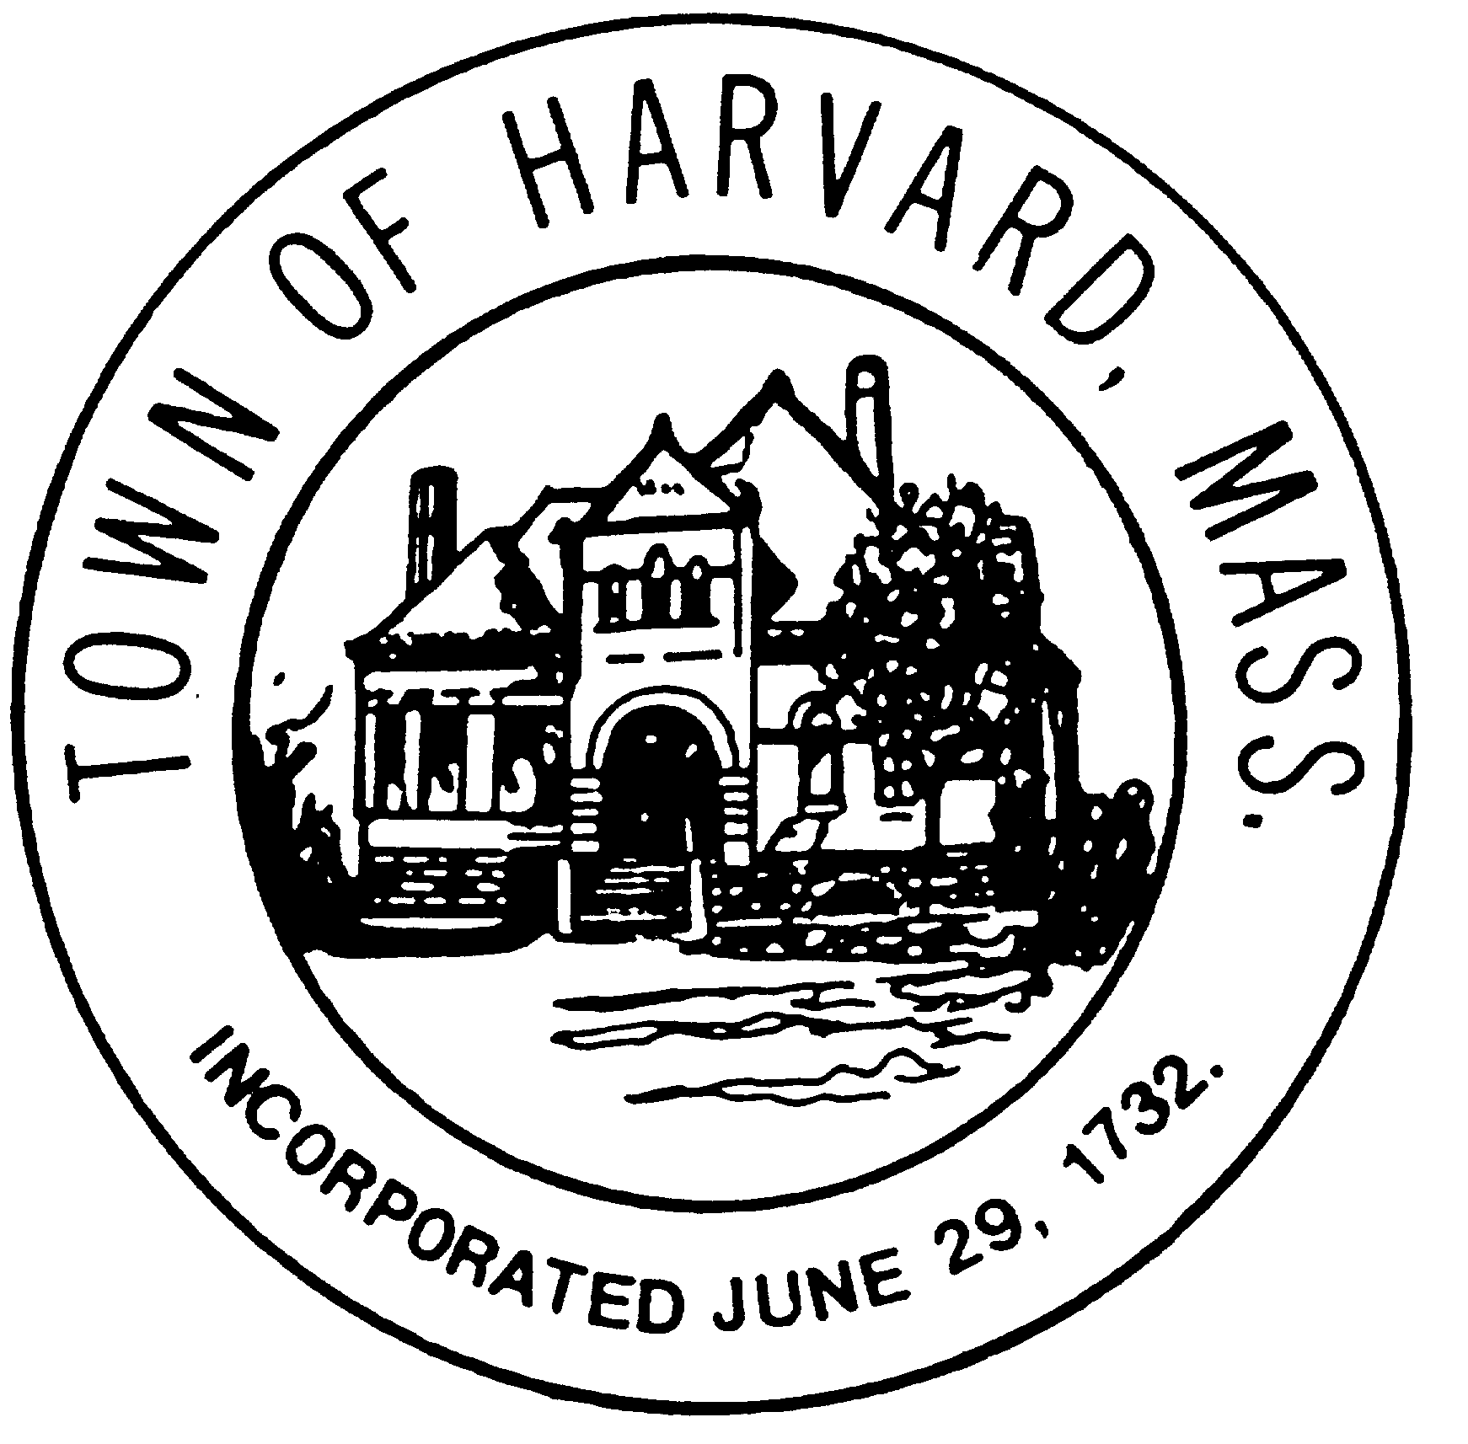
Board: Municipal Buildings Committee
Day & Date: Thursday, January 13, 2011
Time: 9:30 – 11:30 am
Location: Town Hall meeting room
Agenda:

- Reading and approval of minutes of January 6th meetings.
- Next meetings: January 20, 27
- Design Team status report – Doug and Ron
- Grant research update – Peter and Maggie
- Financing proposal for Town Hall – Ron and Marie
- Report on meeting with HEAC (Ron), Fire Department (Peter and Ron), Cable Committee (Peter and Ron)
- Discussion of project management structure for Town Hall design/construction (Pete and Ron)
- Discussion of 7 year schedule (Pete and Ron)
- Pilot Project update – Willie
- Preliminary draft of Warrant Article(s) - Lucy

This following has been updated since our last meeting. We will go through it and identify status of outstanding items.

- PREPARATION FOR MEETING WITH BOS ON FEBRUARY 1, 2011 - 2 week schedule

  - Completion of Report – assignments and deadlines
    - Format, method of publication, printing date. Considerations: -------
      - Incorporation of modifications after review by BOS, etc
      - Request for submission of Town Reports by January 14th.
    - Program descriptions/space requirements Pete, Willie, Lucy
    - Completion of floor plans and site plans Design Team
    - Final packaging of engineering & estimating reports Design Team
    - Completion of Schemes/Packaging/Cost/Scenarios Design Team
    - Preparation of Pilot Project Report Willie
    - Completion of Profile of Harvard’s Public/Private Spaces Maggie
    - Completion of Implementation Strategy
      - Funding resource analysis Marie and Peter
        - Precedents (CPC funding; philanthropy, etc)
        - Grants (Green Communities, etc)
        - Real Estate (value of old library)
      - Funding strategy Ron/Marie
      - Schedule and phasing strategy (5-7 years) Pete
      - Recommendations, funding request, Warrant Articles Lucy/Ron
    - Completion of Town Center/Emerald Necklace description Ron
    - Possible elaboration of ‘Historical Perspective’ Carlene

  - Meeting with Boards & Committees – dates and assignments
    - Historical Commission – re: status Jan 4th ; 8:30pm Doug/Ron
    - Energy Advisory Committee – re: design Jan 6th ; 7:30pm Ron
    - Fire Department – re: site plan Jan 12th ; 7:00pm Peter/Ron
    - Capital – re: endorsm’t & design funding Jan 27th ; 8:00am Marie/Ron
    - CPC – re: non-binding funding commitm’t unscheduled Marie/Ron
    - Finance Committee – re: operating costs unscheduled Marie
    - Planning Board unscheduled Marie
    - Park and Rec unscheduled Peter
    - Library Trustees unscheduled Pete
    - COA –re: funding strategy unscheduled Lucy
    - Unitarian Church – re: site plan unscheduled Ron
    - School Committee – re: Adult Ed program unscheduled -------
    - Cable Committee - re: preferred location Jan 10th; 4:30pm -------
    - Conservation Commission –re: Reed land unscheduled -------

  - Meeting with Constituencies – assignments, dates and venues
    - Common residents ----------------- -------
    - “Seniors” ----------------- -------
    - Supporters of cultural programs ----------------- -------
    - Other ----------------- -------
    - Other ----------------- -------

- PREPARATION FOR ANNUAL TOWN MEETING ON APRIL 2, 2011 - 8 week schedule

  - Outreach strategy – assignments and schedule
    - Communications materials
      - Flyers, signs -------
      - Presentations (boards, power point) -------
      - Press -------
      - Mailings -------
    - Gatherings (Possible venues: Hildreth, old Library, Town Hall stage)
      - Forums/Teas/etc – once a week; various days and times
        - Feb 7-13th -------
        - Feb 14- 20th -------
        - Feb 21- 27th -------
        - Feb 28th – Mar 6th -------
        - Mar 7-13th -------
        - Mar 14- 20th -------
        - Mar 21- 27th -------
      - Attendance at regular meeting of:
        - Garden Club Carlene
        - League of Women Voters Marie
        - Historical Society Maggie
        - Conservation Trust -------
        - Lions Club – February 24th Peter/Ron
        - Churches Lucy
        - Men’s Breakfast Peter
        - Other -------
        - Other -------
        - Other -------

  - Additional Substantiation of Recommendations to Town Meeting – assignments and schedule
    - Elaborate approach to creation of a non-profit cultural center. -------
For example:
      - Form “Friends of the Cultural Center”; obtain funding for:
        - The development of a Strategic and Business Plan
(Possibly with a consultant)
        - Near term staffing
      - Define the vision and mission of the Culture Center
      - Profile precedents
    - Continue investigation of funding sources. For example: -------
      - Private
      - Foundations
      - Energy rebates and ESCO’s
      - Real Estate development potentials
    - Continue research on evolving programs and constituency profiles -------
of senior service centers. For example:
      - Demographic studies
      - Service profile of various organizations/venues

